**Disclaimer: The content is curated from online/offline resources and used for educational purpose only**

**Code Repository**

**LAB MANUAL**

**Cloning Repositories and Setting Up Local Workflows**

**Objective:**

* To understand how to clone a remote Git repository to a local machine
* To set up a local workflow for modifying, committing, and pushing changes
* To explore the relationship between local and remote repositories

**Equipment Required:**

* Computer with internet access
* Git installed on the system
* GitHub or GitLab account (or any remote repository provider)
* Git Bash (Windows) or Terminal (macOS/Linux)
* Code/text editor (e.g., VS Code, Notepad++)

**Prerequisites:**

1. Basic knowledge of Git and GitHub
2. Git must be installed and configured (user.name and user.email)
3. Access to a remote Git repository URL (e.g., from GitHub)

**Problem Statement:**

You are joining a team project hosted on GitHub. Your task is to clone the remote repository to your local machine, set up a local development environment, make changes to a file, and push your changes back to the remote repository. This exercise will help you understand the common local workflow in a collaborative software development environment.

**Procedure:**

**Step 1: Clone the Repository**

1. **Navigate to the target repository on GitHub.**
2. **Click on the green Code button and copy the URL (HTTPS or SSH).**



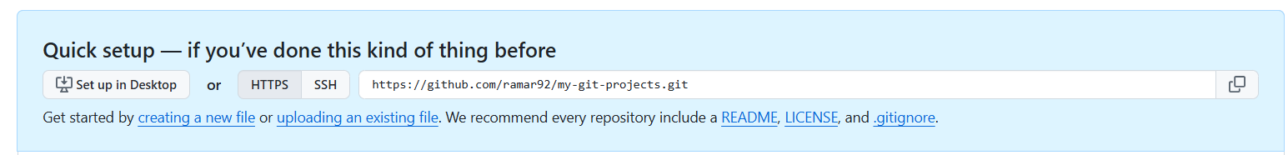

1. **Open the terminal (or Git Bash).**
2. 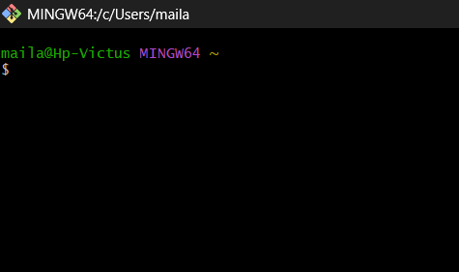
3. **Run the following command:** https://github.com/ramar92/my-git-projects.git

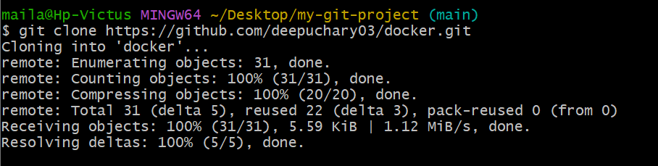

**Step 2: Set Up Git Configuration (If Not Already Set)**

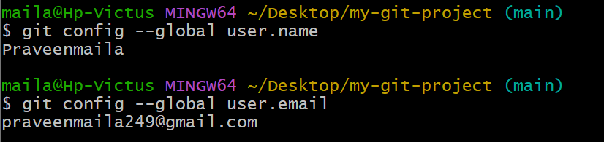

**Step 3: Create and Modify Files**

1. Open the folder in your code editor (e.g., code . for VS Code).
2. Create a new file named hello.txt.
3. Add the following content: Hello, this is my first contribution.

**Step 4: Track Changes with Git**

